Isaac Ray Shoebottom

CS 1073 (FR02A)

Assignment 11

3429069

# Section A

## Source Code:

/**

* Inverted Stairs

* @author Isaac Shoebottom (3429069)

*/

public class PatternInverted {

public static void main(String[] args) {

for (int i = 1; i < 10; i++) {

for (int a = 9; a > i; a--) {

System.out.print(' ');

}

for (int j = 1; j <= i; j++) {

System.out.print('*');

}

System.out.println();

}

}

}

## Output:

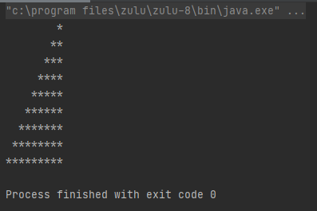

# Section B

## Source Code:

import java.util.Scanner;

/**

* Simple test stats

* @author Isaac Shoebottom (3429069)

*/

public class ClassGrades {

public static void main(String[] args) {

Scanner scan = new Scanner(System.in);

long testScore;

long numberOfA = 0;

long numberOfB = 0;

long numberOfC = 0;

long numberOfD = 0;

long numberOfF = 0;

do {

System.out.print("Enter test score: ");

testScore = scan.nextLong();

if (testScore > 100) {

System.out.println("Please enter a test score within the range 0-100");

}

else {

if (testScore >= 85) {

numberOfA++;

}

else if (testScore >= 70) {

numberOfB++;

}

else if (testScore >= 55) {

numberOfC++;

}

else if (testScore >= 45) {

numberOfD++;

}

else if (testScore >= 0) {

numberOfF++;

}

}

} while (testScore >= 0);

System.out.println("Number of A's: " + numberOfA);

System.out.println("Number of B's: " + numberOfB);

System.out.println("Number of C's: " + numberOfC);

System.out.println("Number of D's: " + numberOfD);

System.out.println("Number of F's: " + numberOfF);

}

}

## Output:

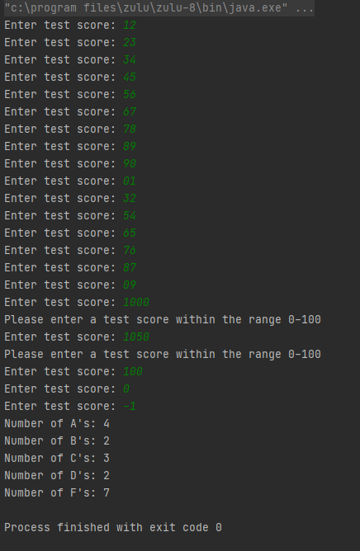

# Section C

## Source Code:

import java.util.Scanner;

/**

* Sideways histogram for tests

* @author Isaac Shoebottom (3429069)

*/

public class ClassGradesHistogram {

public static void main(String[] args) {

Scanner scan = new Scanner(System.in);

long testScore;

long numberOfA = 0;

long numberOfB = 0;

long numberOfC = 0;

long numberOfD = 0;

long numberOfF = 0;

do {

System.out.print("Enter test score: ");

testScore = scan.nextLong();

if (testScore > 100) {

System.out.println("Please enter a test score within the range 0-100");

} else {

if (testScore >= 85) {

numberOfA++;

} else if (testScore >= 70) {

numberOfB++;

} else if (testScore >= 55) {

numberOfC++;

} else if (testScore >= 45) {

numberOfD++;

} else if (testScore >= 0) {

numberOfF++;

}

}

} while (testScore >= 0);

System.out.println("Scores");

System.out.print("A\t\t|");

while (numberOfA > 0) {

System.out.print('*');

numberOfA--;

}

System.out.println();

System.out.print("B\t\t|");

while (numberOfB > 0) {

System.out.print('*');

numberOfB--;

}

System.out.println();

System.out.print("C\t\t|");

while (numberOfC > 0) {

System.out.print('*');

numberOfC--;

}

System.out.println();

System.out.print("D\t\t|");

while (numberOfD > 0) {

System.out.print('*');

numberOfD--;

}

System.out.println();

System.out.print("F\t\t|");

while (numberOfF > 0) {

System.out.print('*');

numberOfF--;

}

System.out.println();

System.out.println("\t\t" + "===============================");

System.out.println("\t\t" + "+ + + +");

System.out.println("\t\t" + "0 10 20 30");

}

}

## Output (Too long for picture):

Enter test score: 12

Enter test score: 23

Enter test score: 34

Enter test score: 56

Enter test score: 67

Enter test score: 89

Enter test score: 90

Enter test score: 21

Enter test score: 43

Enter test score: 54

Enter test score: 65

Enter test score: 76

Enter test score: 87

Enter test score: 98

Enter test score: 09

Enter test score: 49

Enter test score: 28

Enter test score: 48

Enter test score: 43

Enter test score: 86

Enter test score: 23

Enter test score: 765

Please enter a test score within the range 0-100

Enter test score: 54

Enter test score: 65

Enter test score: 32

Enter test score: 73

Enter test score: 96

Enter test score: 62

Enter test score: 74

Enter test score: 52

Enter test score: 52

Enter test score: 74

Enter test score: 52

Enter test score: 74

Enter test score: 52

Enter test score: 75

Enter test score: 2

Enter test score: 74

Enter test score: 41

Enter test score: 74

Enter test score: 41

Enter test score: 63

Enter test score: 41

Enter test score: -1

Scores

A |******

B |********

C |******

D |********

F |**************

===============================

+ + + +

0 10 20 30

# Section D

## Source Code:

import java.util.Scanner;

/**

* Vertical histogram for tests

* @author Isaac Shoebottom (3429069)

*/

public class ClassGradesHistogramVertical {

public static void main(String[] args) {

Scanner scan = new Scanner(System.in);

long testScore;

long numberOfA = 0;

long numberOfB = 0;

long numberOfC = 0;

long numberOfD = 0;

long numberOfF = 0;

do {

System.out.print("Enter test score: ");

testScore = scan.nextLong();

if (testScore > 100) {

System.out.println("Please enter a test score within the range 0-100");

} else {

if (testScore >= 85) {

numberOfA++;

} else if (testScore >= 70) {

numberOfB++;

} else if (testScore >= 55) {

numberOfC++;

} else if (testScore >= 45) {

numberOfD++;

} else if (testScore >= 0) {

numberOfF++;

}

}

} while (testScore >= 0);

for (int i = 30; i > 0; i--) {

if (i == 30 | i == 20 | i == 10)

System.out.print(i+ "+");

System.out.print("\t| ");

if (numberOfA >= i) {

System.out.print('*');

}

else {

System.out.print(' ');

}

System.out.print(' ');

if (numberOfB >= i) {

System.out.print('*');

}

else {

System.out.print(' ');

}

System.out.print(' ');

if (numberOfC >= i) {

System.out.print('*');

}

else {

System.out.print(' ');

}

System.out.print(' ');

if (numberOfD >= i) {

System.out.print('*');

}

else {

System.out.print(' ');

}

System.out.print(' ');

if (numberOfF >= i) {

System.out.print('*');

}

else {

System.out.print(' ');

}

System.out.print(' ');

System.out.println();

}

System.out.println("0+\t===========");

System.out.println("\t A B C D F");

}

}

## Output (Too long for picture):

Enter test score: 12

Enter test score: 34

Enter test score: 56

Enter test score: 78

Enter test score: 90

Enter test score: 09

Enter test score: 87

Enter test score: 65

Enter test score: 43

Enter test score: 21

Enter test score: 13

Enter test score: 35

Enter test score: 7

Enter test score: 75

Enter test score: 42

Enter test score: 65

Enter test score: 42

Enter test score: 86

Enter test score: 432

Please enter a test score within the range 0-100

Enter test score: 73

Enter test score: 95

Enter test score: 05

Enter test score: 15

Enter test score: 73

Enter test score: 53

Enter test score: 86

Enter test score: 53

Enter test score: 86

Enter test score: 52

Enter test score: 85

Enter test score: 53

Enter test score: 86

Enter test score: 27

Enter test score: 73

Enter test score: 52

Enter test score: 85

Enter test score: -1

30+ |

|

|

|

|

|

|

|

|

|

20+ |

|

|

|

|

|

|

| *

| *

| *

10+ | *

| * *

| * *

| * *

| * *

| * * * *

| * * * *

| * * * * *

| * * * * *

| * * * * *

0+ ===========

A B C D F

# Section E

## Source Code (Utilities):

/**

* Array utils for ints

* @author Isaac Shoebottom (3429069)

*/

public class IntArrayUtil {

/**

* Appends an array to another array

* @param arrA First array in append

* @param arrB Second array in append

* @return Appended array

*/

public static int[] append (int[] arrA, int[] arrB) {

int appendedLength = arrA.length + arrB.length;

int[] appended = new int[appendedLength];

for(int i = 0; i < arrA.length; i++) {

appended[i] = arrA[i];

}

for(int i = 0; i < arrB.length; i++) {

appended[i + arrA.length] = arrB[i];

}

return appended;

}

/**

* Reverse the order of elements in a string

* @param arr The array to be reversed

* @return The reversed array

*/

public static int[] reverse (int[] arr) {

int[] reversed = new int[arr.length];

for(int i =0; i<arr.length; i++ ) {

reversed[i] = arr[i];

}

for(int i = 0; i < arr.length/2; i++) {

int temp = reversed[i];

reversed[i] = arr[(arr.length-1) - i];

reversed[(arr.length-1) - i] = temp;

}

return reversed;

}

/**

* Subtracts every odd index from a string from every even index

* @param arr The array to perform math on

* @return The alternating sum of the array

*/

public static int alternatingSum (int[] arr) {

int positives = 0;

int negatives = 0;

boolean isPos = true;

for (int j : arr)

if (isPos) {

positives += j;

isPos = false;

} else {

negatives += j;

isPos = true;

}

return positives-negatives;

}

}

## Source Code (Driver):

import java.util.Arrays;

public class IntArrayUtilDriver {

public static void main(String[] args) {

int[] array1 = {1, 4 ,9, 16};

int[] array2 = {9, 7, 4, 9 ,11};

int[] array3 = IntArrayUtil.append(array1, array2);

System.out.println("These are the original strings");

System.out.println(Arrays.toString(array1));

System.out.println(Arrays.toString(array2));

System.out.println(Arrays.toString(array3));

System.out.println("These are the modified strings");

System.out.println(Arrays.toString(IntArrayUtil.append(array1, array2)));

System.out.println(Arrays.toString(IntArrayUtil.reverse(array3)));

System.out.println(IntArrayUtil.alternatingSum(array3));

}

}

## Output (Text and Picture):

These are the original strings

[1, 4, 9, 16]

[9, 7, 4, 9, 11]

[1, 4, 9, 16, 9, 7, 4, 9, 11]

These are the modified strings

[1, 4, 9, 16, 9, 7, 4, 9, 11]

[11, 9, 4, 7, 9, 16, 9, 4, 1]

-2

